MY LEARNING LABYRINTH
This year I studied the significance of using the labyrinth as a reflective guide and I found the circular traipsing of the pathway reminiscient of internal work that draws on wisdom personal and borrowed. Here in this page, I share some of this reflective work – from my thoughts as well as others in the field.
This selective repository of my reflections on projects and facilitation in general provide a running record of sessions completed and groups that I have served as facilitator.
I also include some reference reading and tips form other facilitators that I have used and hold as rich food. All are acknowledged with name and source as provided. I acknowledge them here with a debt of gratitude. Patricia Nunis

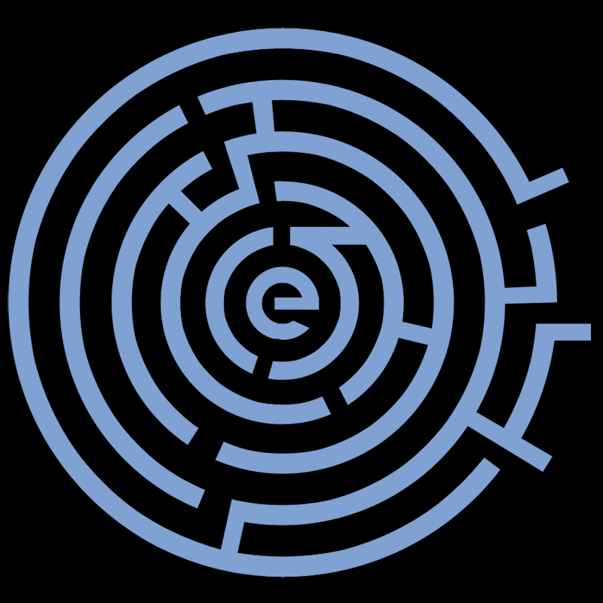

PAT’S WRITINGS
- 21032020 – Learning while Building Bridges
- 01022020 – The Inclusive Lions of the Year of the Rat
- 2020 – Alchemy & the Facilitator
- 2010-2012 – A Review
- 2008 – Training or Facilitation?

WORK OF THE FACILITATOR COMMUNITY AND OTHER SCHOLARS
- The Wall of Wonder by Patricia Tuecke, 2000
- Theory U Framework – summary from North Star Facilitators, Facilitator Generosity Library, 2000
- The Circle Ways Pocket Guide, by Christina Baldwin & Ann Linnea, 2016
- Zoom Links for Virtual Sessions - from North Star, Facilitator Generosity Library,2000
- Becoming the Leader You Want – Izzy Gesell, email link, 25 March 2020
- How Meditation Works -by Liz Kulze, in the Atlantic, 7 Sept 2013
- The Humble Inquiry (excerpt) by Edgar Schein, Barrett-Koehler Publications, 2013
- Servant Leadership by Jane Wadell, Leadership Studies, Regent University, August 2006
- Antecedents of Transactional, Transformational, and Servant Leadership: A Constructive-Development Theory Approach by Marilyn J. Bugenhagen, University of Nebraska – Lincoln 2006
- The Art of Focused Conversation by Brian Stanfield, ICA Associates, Canada

